

**JavaScript: Compute the average and grade of the students**

Last update on February 09 2019 08:32:08 (UTC/GMT +8 hours)

JavaScript Conditional Statement and loops: Exercise-6 with Solution

Write a JavaScript program which compute, the average marks of the following students Then, this average is used to determine the corresponding grade.

|  |  |
| --- | --- |
| **Student Name** | **Marks** |
| David | 80 |
| Vinoth | 77 |
| Divya | 88 |
| Ishitha | 95 |
| Thomas | 68 |

The grades are computed as follows:

|  |  |
| --- | --- |
| **Range** | **Grade** |
| <60 | F |
| <70 | D |
| <80 | C |
| <90 | B |
| <100 | A |

**Pictorial Presentation:**

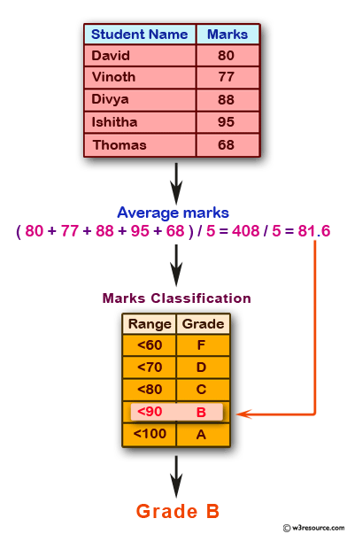

**Sample Solution:-**

**HTML Code:**

<!DOCTYPE html>

<html>

<head>

<meta charset=utf-8 />

<title>Compute the average marks and grade</title>

</head>

<body>

</body>

</html>

Copy

**JavaScript Code:**

var students = [['David', 80], ['Vinoth', 77], ['Divya', 88], ['Ishitha', 95], ['Thomas', 68]];

var Avgmarks = 0;

for (var i=0; i < students.length; i++) {

Avgmarks += students[i][1];

var avg = (Avgmarks/students.length);

}

console.log("Average grade: " + (Avgmarks)/students.length);

if (avg < 60){

console.log("Grade : F");

}

else if (avg < 70) {

console.log("Grade : D");

}

else if (avg < 80)

{

console.log("Grade : C");

} else if (avg < 90) {

console.log("Grade : B");

} else if (avg < 100) {

console.log("Grade : A");

}

Copy

Sample Output:

Average grade: 81.6

Grade : B

**Flowchart:**

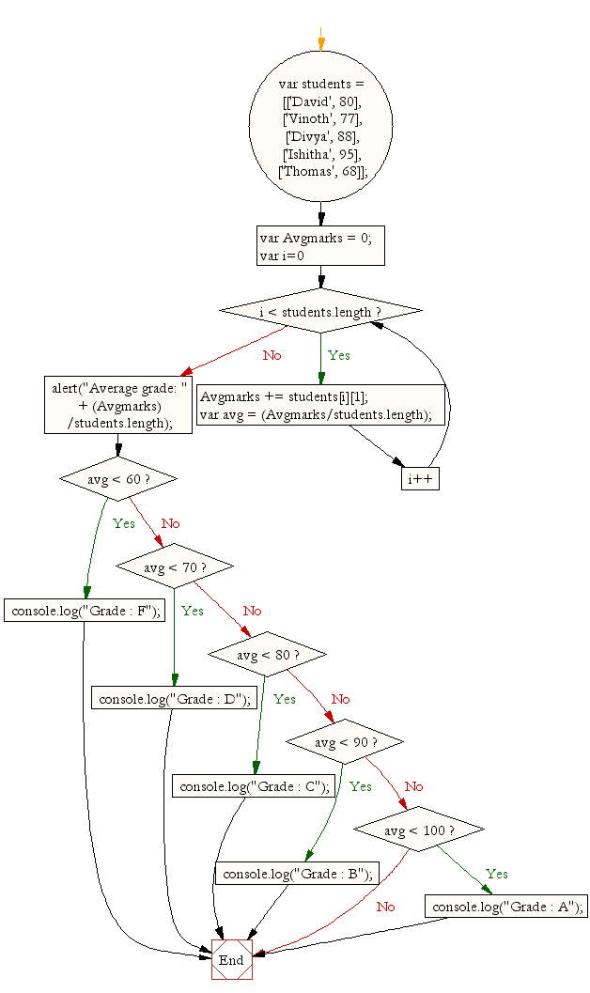

**Live Demo:**

See the Pen [javascript-conditional-statements-and-loops-exercise-6](https://codepen.io/w3resource/pen/GGEqmW/) by w3resource ([@w3resource](https://codepen.io/w3resource)) on [CodePen](https://codepen.io/).

**Improve this sample solution and post your code through Disqus**

**Previous:**[Write a JavaScript for loop that will iterate from 0 to 15.](https://www.w3resource.com/javascript-exercises/javascript-conditional-statements-and-loops-exercise-5.php)  
**Next:**[Write a JavaScript program which compute, the average marks of the following students Then, this average is used to determine the corresponding grade.](https://www.w3resource.com/javascript-exercises/javascript-conditional-statements-and-loops-exercise-7.php)

**What is the difficulty level of this exercise?**

Top of Form

EASY MEDIUM HARD

Bottom of Form

Based on 349 votes, average difficulty level of this exercise is Easy .

﻿

New Content: [Composer: Dependency manager for PHP](https://www.w3resource.com/php/composer/a-gentle-introduction-to-composer.php), [R Programming](https://www.w3resource.com/r-programming-exercises/)

[This work is licensed under a Creative Commons Attribution-NonCommercial-ShareAlike 3.0 Unported License.](https://creativecommons.org/licenses/by-nc-sa/3.0/deed.en_US)

©w3resource.com 2011-2019

* [Privacy](https://www.w3resource.com/privacy.php)
* [About](https://www.w3resource.com/about.php)
* [Contact](https://www.w3resource.com/contact.php)
* [Feedback](https://www.w3resource.com/feedback.php)
* [Advertise](https://www.w3resource.com/advertise.php)

[](https://www.w3resource.com/javascript-exercises/javascript-conditional-statements-and-loops-exercise-6.php#h_one)